DAY 5 : REVIEW AND PRACTICE PRATICAL
- Open Cisco Packet Tracer and create a new project file named 'HomeWiFiNetwork.pkt' with three PCs and one wireless router connected appropriately.
Answer
1.Launch & Create New Topology:1 min.
Open Cisco Packet Tracer on your computer. Select File > New to start with a blank workspace.
2.Add Devices to Workspace:2 mins.
Locate the device menu at the bottom-left corner and drag the following items onto the workspace grid:
3.Connect PCs to Router:3 mins.
Connect the devices using standard Ethernet cables or configure wireless connectivity:
4.Save Project File:1 min.
Go to File > Save As..., navigate to your desired directory, enter Home Wi-Fi Network. pkt as the file name, and click Save.
Verification
- Check that all cable connection indicators show green link lights (or wireless signals form dashed blue lines between devices and the router).
- Click on any PC, open the Desktop tab, navigate to Command Prompt, and run ping 192.168.0.1 (the default router IP) to confirm connectivity.

- Assign static IP addresses to each PC in your Packet Tracer network so they are on the same subnet (e.g., 192.168.10.x), and configure the default gateway to the router's IP.
Answer

To assign static IP addresses and configure the default gateway for each PC on the 192.168.10.x subnet, follow these steps:
1.Configure Router Gateway IP:2 mins.
Click on the WRT300N Router and set up the gateway interface:
2.Configure Static IP for PC0:1 min.
Click on PC0 to open its window:
3.Configure Static IP for PC1 & PC2:2 mins.
Repeat the static assignment steps for the remaining PCs:
Verification
Open PC0, go to Desktop > Command Prompt, and run ping 192.168.10.1 and ping 192.168.10.3. Receiving successful replies confirms proper static routing and network connectivity across the subnet.

Test connectivity by using the Packet Tracer 'ping' tool to verify that all PCs can communicate with each other and the router.<br><br><em><strong>Hint:</strong> Use the Command Prompt tool on each PC and type 'ping [other PC’s IP]'.</em>
Answer
Connectivity Test in Cisco Packet Tracer
Using the IP addresses from the previous setup:
- PC0: 192.168.10.2
- PC1: 192.168.10.3
- PC2: 192.168.10.4
- Router: 192.168.10.1
On each PC, open Desktop → Command Prompt and run:

- Test connectivity by using the Packet Tracer 'ping' tool to verify that all PCs can communicate with each other and the router.<br><br><em><strong>Hint:</strong> Use the Command Prompt tool on each PC and type 'ping [other PC’s IP]'.</em>
Answer
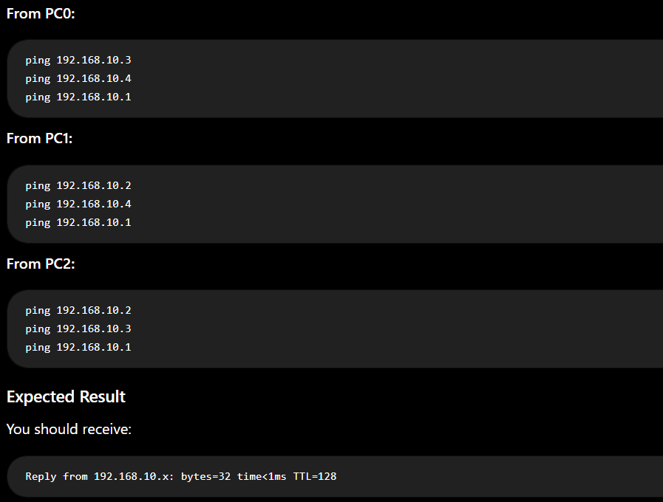
Conclusion: If all pings receive replies, PC0, PC1, PC2, and the router can communicate successfully on the 192.168.10.0/24 network. If you see Request timed out, check the IP address, subnet mask, cable/wireless connection, and router interface configuration.

- Document each step you took to build and configure your Packet Tracer network, including screenshots of your topology and the IP configuration windows for each PC, in a Word or PDF file.
Answer
I can prepare the Word/PDF report, but to include the actual screenshots of your Packet Tracer topology and each PC's IP configuration, I need you to upload those screenshots.
Please upload:
- Complete topology screenshot
- PC0 IP Configuration screenshot
- PC1 IP Configuration screenshot
- PC2 IP Configuration screenshot
- Ping/connectivity screenshot, if available
Once uploaded, I can organize them with the step-by-step instructions and create a submission-ready PDF.

